Plague Denmark Paper

This manuscript ([permalink](https://rawcdn.githack.com/ktmeaton/obsidian-public/df41ffe5/academic/Plague%20Denmark%20Paper.html)) was automatically generated from [ktmeaton/obsidian-public@df41ffe5](https://github.com/ktmeaton/obsidian-public/tree/df41ffe5) on June 29, 2021.

## Authors

* **Katherine Eaton** ORCID icon [0000-0001-6862-7756](https://orcid.org/0000-0001-6862-7756) · GitHub icon [ktmeaton](https://github.com/ktmeaton) McMaster Ancient DNA Center; Department of Anthropology, McMaster University
* **Ravneet Sidhu** McMaster Ancient DNA Center; Department of Biology, McMaster University
* **Hendrik Poinar** ORCID icon [0000-0002-0314-4160](https://orcid.org/0000-0002-0314-4160) McMaster Ancient DNA Center; Department of Anthropology, McMaster University

## Data Collection

326 individuals were sampled across 8 municipalities from 14 archaeological sites with occupation dates spanning from 900 to 1600 CE (Table 1). The most heavily represented periods are the Danish early medieval period (1050–1225) and the Danish medieval period (1225–1536) 1.

**Kat’s Notes**: - Positivity rate (all sites): 4.6% (15/326) - Positivity rate (excluding negative sites): 9.4% (15/159)

Table 1: Site summary.

|  |  |  |  |  |  |
| --- | --- | --- | --- | --- | --- |
| Municipality | Site Name | Site Code | Site Date | Sampled | Plague Positive |
| Ribe | Ribe Gräbrødre | ASR 1015 | 1200 : 1560 | 53 | 6 |
|  | Ribe Lindegården (Vikings) | ASR 13/13II | 900 : 1000 | 15 | 0 |
|  | Ribe Lindegården (City Cemetery) | ASR 13II | 1200 : 1560 | 28 | 1 |
|  | Ribe Lindegärden | ASR 2391 | 900 : 1000 | 5 | 0 |
| Nordby | Nordby | FHM 3970 | 1050 : 1250 | 36 | 0 |
| Horsens | Monastery Church | HOM 1272 | 1600 : 1800 | 50 | 0 |
|  | Ole Wormsgade | HOM 1649 | 1100 : 1500 | 17 | 2 |
|  | Sejet | HOM 1046 | 1150 : 1574 | 25 | 1 |
|  | Tirup | VKH 1201 | 1150 : 1350 | 12 | 1 |
| Hågerup | Hågerup | ØHM 1247 | 1100 : 1555 | 7 | 1 |
| Refshale | Refshale | Refshale | 1100 : 1350 | 19 | 0 |
| Viborg | Sct. Michael | JAH 1-77 | 1000 : 1529 | 4 | 0 |
|  | The Catholic Church | VSM 09264 | 1100 : 1529 | 6 | 0 |
|  | Sct. Mathias | VSM 855F/906F | 1100 : 1529 | 23 | 0 |
|  | Sct. Drotten | VSM 902F | 1100 : 1529 | 8 | 0 |
|  | Faldborg | VSM 29F | 1100 : 1600 | 17 | 2 |
| **Total** |  |  |  | 326 | 15 |

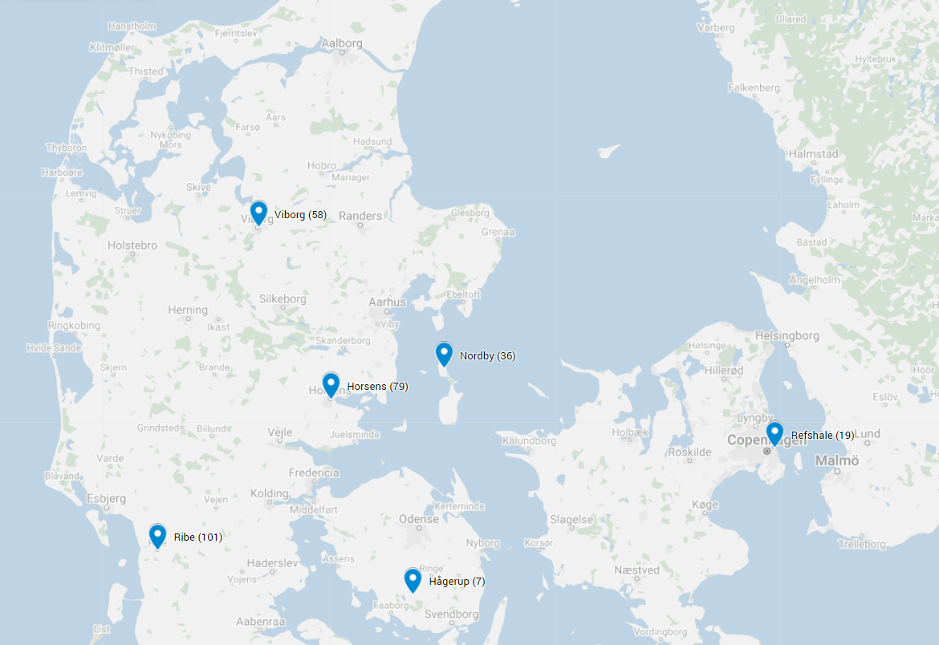

Figure 1: Map Denmark Sites (PLACEHOLDER)

### Plague Detection

13 individuals were identified as plague-positive based on a combination of PCR assays, shotgun sequencing, and targeted enrichment for the *Yersinia pestis* whole genome (Table ?? and ??). 4 individuals had chromosomal coverage insufficient for phylogenetic analysis (<3X mean).

**Kat’s Notes**: - Full genomes can only be retrieved from samples with 6/6 positive PCR replicates. - *Y. pestis* is only detected during the Danish medieval period (1225–1536). - Are G25A and G25B two individuals from the same grave??

Table 2: Plague positive summary.

|  |  |  |  |  |  |  |  |  |  |
| --- | --- | --- | --- | --- | --- | --- | --- | --- | --- |
| Arch ID | Project ID | Site Code | PCR | Human (%) | Plague (%) | Chrom | pCD1 | pMT1 | pPCP1 |
| G16 | D71 | ASR 1015 | 6/6 | 5.95 | 0.18 | 22.6 | 39.4 | 14.7 | 4.6 |
| G861 x1035 | D75 | ASR 1015 | 6/6 | 4.42 | 0.23 | 17.4 | 40.2 | 16.5 | 3.4 |
| G25B x98 | R36 | ASR 1015 | 6/6 | 8.41 | 0.25 | 24.0 | 51.8 | 14.9 | 5.8 |
| G25A | D62 | ASR 1015 | 6/6 | 1.12 | 0.10 | 3.8 | 10.5 | 2.5 | 0.9 |
| G207 | D72 | ASR 1015 | 6/6 | 12.94 | 0.04 | 6.0 | 13.5 | 5.8 | 2.2 |
| A19 X21 | D24 | ØHM 1247 | 6/6 | 0.55 | 0.01 | **2.6** | 6.1 | 1.9 | 0.7 |
| A146 x3011 | P187 | HOM 1046 | 6/6 | 0.68 | 0.01 | 4.9 | 18.4 | 6.6 | 52.2 |
| A1155 x1155 | P384 | HOM 1649 | 4/6 | 0.11 | 0.01 | **1.1** | 4.8 | 1.4 | 19.6 |
| A1480 x1480 | P387 | HOM 1649 | 6/6 | 0.04 | 0.01 | 6.5 | 21.7 | 5.0 | 75.0 |
| G371 | P212 | VKH 1201 | 6/6 | 0.61 | 0.04 | 6.7 | 26.3 | 8.5 | 56.6 |
| Gr GC 15 | D51 | VSM 29F | 6/6 | 0.67 | 0.05 | 9.0 | 25.4 | 8.1 | 2.0 |
| Gr ID 319 | R21 | VSM 29F | 6/6 | 0.85 | 0.01 | **2.6** | 3.8 | 2.3 | 0.4 |
| X1265 | P246 | ASR 13 II | 6/6 | 0.03 | 0.01 | **0.1** | 0.1 | 0.1 | 3.2 |

Table 3: Plague false positive summary.

|  |  |  |  |  |  |  |  |  |  |
| --- | --- | --- | --- | --- | --- | --- | --- | --- | --- |
| Arch ID | Project ID | Site Code | PCR | Human (%) | Plague (%) | Chrom | pCD1 | pMT1 | pPCP1 |
| G70 x212 | R44 | ASR 1015 | 3/6 | 1.48 | 0.00 | 0.1 | 0.1 | 0.1 | 0.0 |
| G860 | R39 | ASR 1015 | 5/6 | 0.09 | ? | ? | ? | ? | ? |
| G364 | R43 | ASR 1015 | 4/6 | ? | ? | ? | ? | ? | ? |
| K1167 x1167 | P235 | ASR 13 II | 3/6 | ? | ? | ? | ? | ? | ? |
| A21 x23 | D25 | ØHM 1247 | 4/6 | 0.01 | 0.00 | 0.05 | 0.1 | 0.0 | 0.0 |
| G260 K539 x876 | R27 | VSM 09264 | 3/6 | ? | ? | ? | ? | ? | ? |

### Dating

To estimate dates for the plague-positive individuals, a Bayesian Evaluation of Temporal Signal (BETS) was first performed. Briefly, each candidate model was tested using the correct collection dates of all samples and then compared to the same model with all collection dates assumed to be contemporaneous. Bayes factors (BF) were calculated by comparing the marginal likelihoods of each model, as estimated with a generalized stepping stone (GSS) computation across 100 chains each sampled over 1,000,000 generations.

The BETS analysis revealed decisive support for temporal signal (dates vs. no dates) using both the strict clock (SC) and uncorrelated lognormal relaxed clock (UCLN) (Table 4). A comparison of the strict vs. relaxed clocks using collection date produced decisive support for the relaxed clock.

Table 4: Bayesian Evaluation of Temporal Signal (BETS) summary.

|  |  |  |  |  |  |
| --- | --- | --- | --- | --- | --- |
| Model | Abbrev. | Dates | Likelihood | Bayes Factor (Dates) | Bayes Factor (Model) |
| Strict Clock | SC | Yes | -5948088 | 749 | – |
|  |  | No | -5948837 | – | – |
| Relaxed Clock | UCLN | Yes | **-5947948** | 715 | 140 |
|  |  | No | -5948663 | – | – |

A time-scaled phylogeny with tip-dating was estimated using a relaxed clock and diffuse normal priors centered around the mean collection date. The tip dates from the 9 high coverage *Y. pestis* genomes are presented in Table 5 as the 95% highest posterior density (HPD) intervals.

All estimated tip dates had overlap with the expected range of site occupation dates, with the exception of G371 (P212) from the site of Tirup (VKH 1201).

Table 5: Tip-dating summary.

|  |  |  |  |  |  |
| --- | --- | --- | --- | --- | --- |
| ID | Site Code | Site Occupation | Arm Position Date | Tip Date | Haplotype |
| G16 | ASR 1015 | 1200 : 1560 | 1250 : 1450 | 1310 : 1388 | U2e2a1a |
| G861 x1035 | ASR 1015 | 1200 : 1560 | 1350 : 1450 | 1489 : 1567 | I1f |
| G25B x98 | ASR 1015 | 1200 : 1560 | 1350 : 1450 | 1327 : 1414 | – |
| G25A | ASR 1015 | 1200 : 1560 | 1350 : 1450 | 1295 : 1375 | H7b2 |
| G207 | ASR 1015 | 1200 : 1560 | 1350 : 1450 | 1477 : 1551 | H1a3c1 |
| A146 x3011 | HOM 1046 | 1150 : 1574 | 1250 : 1350 | 1397 : 1470 | – |
| A1480 x1480 | HOM 1649 | 1100 : 1500 | ? | 1384 : 1473 | – |
| G371 | VKH 1201 | 1150 : 1350 | 1250 : 1350 | 1419 : 1490 | – |
| Gr GC 15 | VSM 29F | 1100 : 1600 | 1350 : 1450 | 1539 : 1655 | V12 |

### Phylogeny

The time-scaled phylogeny reveals geographic and temporal structure during the Second Pandemic (Figure 2).

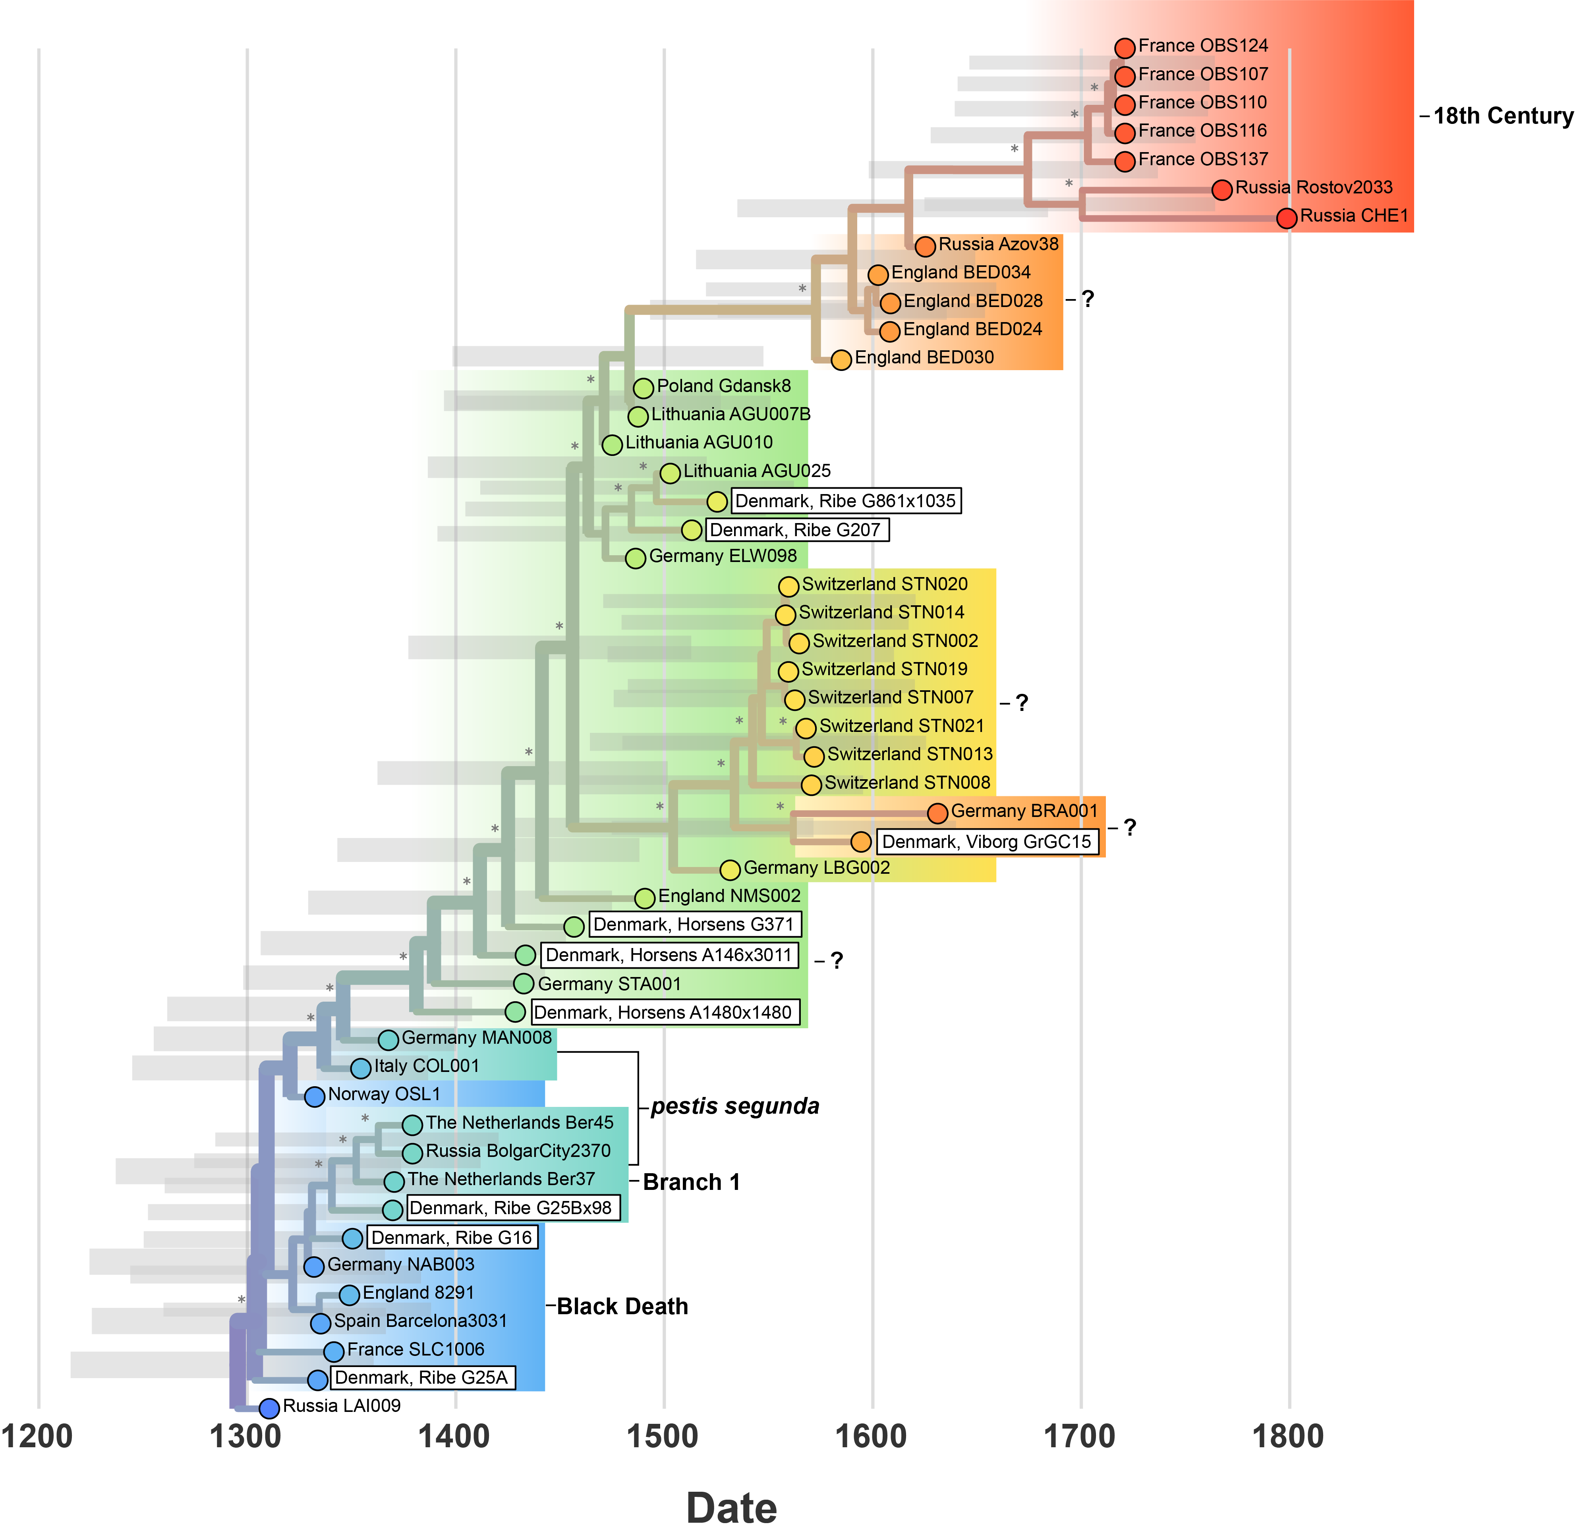

Figure 2: Bayesian time-scaled phylogeny.

**Phase 1: 1300-1450** - All *Y. pestis* genomes from the 14th century cluster together. - Samples from the early-mid 1300s are widely dispersed across Europe (Figure 3), and have highly similar genetic content resulting poorly resolved branching order. This suggests rapid, epidemic spread, thought to be associated with the Black Death. - Samples from the late 1300s also cluster together, and are linked to the *pestis segunda* series of epidemics in Europe. - The only Danish samples in Phase I are from Ribe, and fall within both the Black Death and *pestis segunda* groups. - These are primarily coastal sites, Germany and Russia as the exception.

**Phase 2: 1450-1600** - A very curious branching pattern, lots of ‘independent’ emergences rather than monophyletic clades. - All Danish samples from the Horsens region fall here, and although they have temporal overlap with each other, the lineages of plague are distinct. - …

**Phase 3: 1600-1800** - …

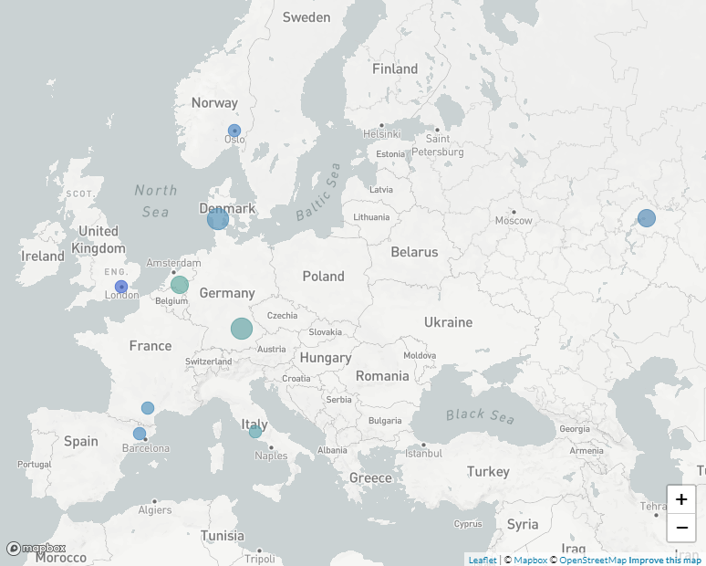

Figure 3: Phase 1: 1300 - 1450

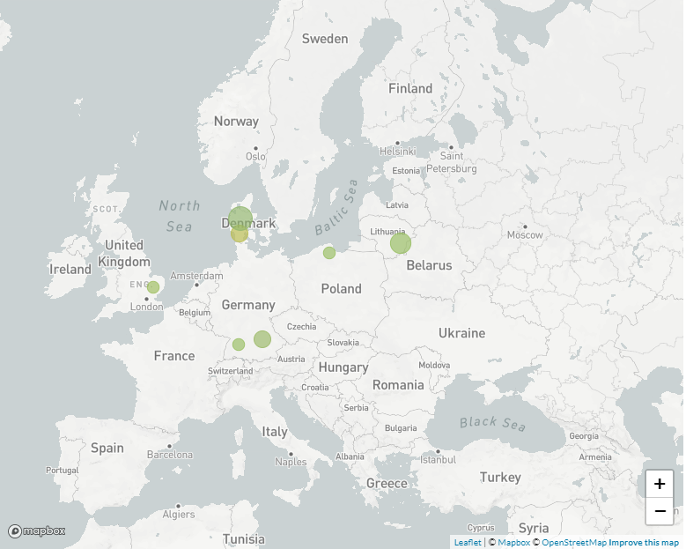

Figure 4: Phase 2: 1450 - 1600

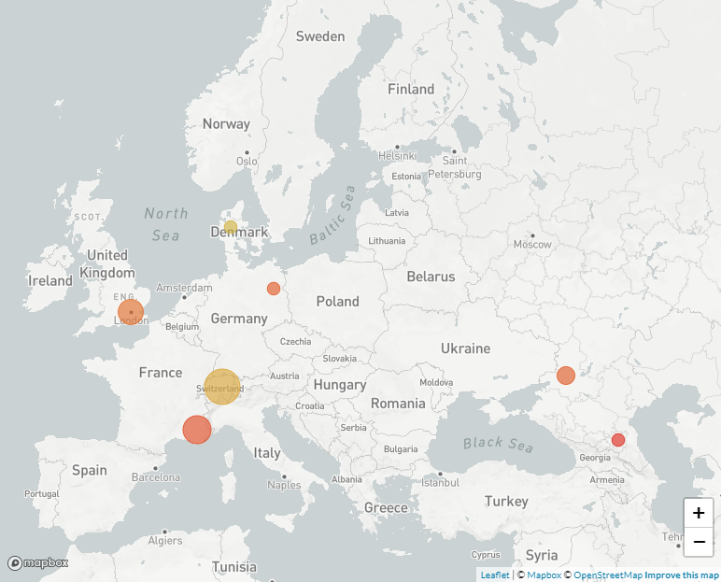

Figure 5: Phase 3: 1600 - 1800

## References

1. **A millennium of population change in pre-modern Danish Ribe**   
Dorthe Dangvard Pedersen, Peter Tarp, Morten Søvsø, Hans Christian Petersen, George Robert Milner, Jesper Lier Boldsen  
*Anthropologischer Anzeiger* (2020-02-13) <http://www.schweizerbart.de/papers/anthranz/detail/77/91627/A_millennium_of_population_change_in_pre_modern_Da?af=crossref>   
DOI: [10.1127/anthranz/2019/0952](https://doi.org/10.1127/anthranz/2019/0952)